Missing Letters

User Manual

Team Red Panda

November 2, 2012

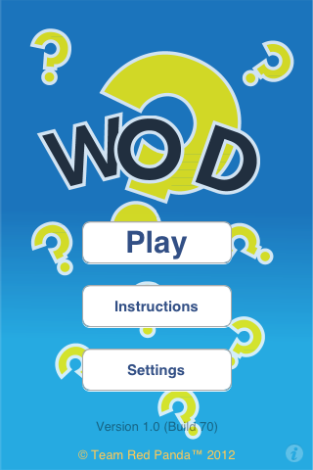**Home Screen/Main Menu:** Click “**Play**” button to start the game.

Click “**Instructions**” button to see the objective of the game.

Click “**Settings**” button to sign in your profile.  
**Pic 1.1 (Home/Main Menu)**

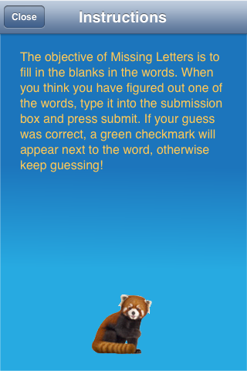**Instruction Screen:** It explains what is the objective of the game and how to play the game.

**Pic 1.2** **(Instruction)**

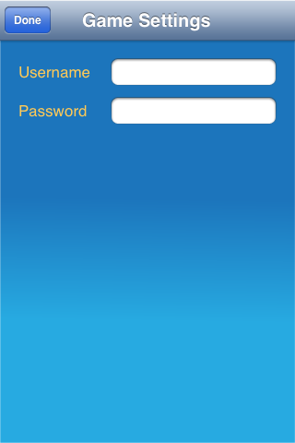**Settings Screen:** Insert **username** and **password** to sign in to user profile. **Pic 1.3 (Settings)**

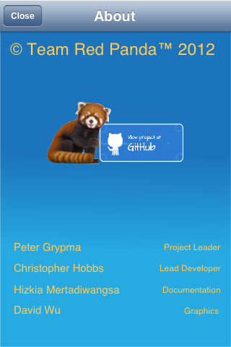**About Screen:** Link to website project.

**Pic 1.4 (About)**

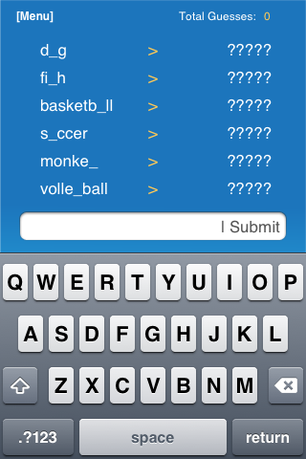**Game Screen:**  Input the answers in the blank text fields and click “**Submit**” button.

At the right top corner show how many times you have been guesses.

At the top left corner there is “**Menu**” button (**see pic 1.8**). **Pic 1.5 (Game)**

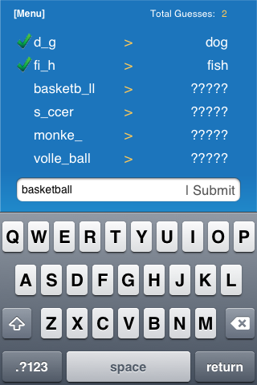To be able answers all the following words, user need to answer subsequently.

**Pic 1.6 (Game)**

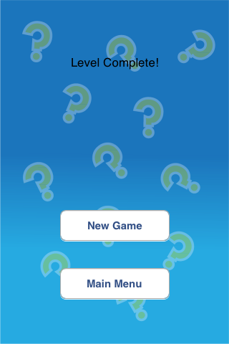**Game End Screen:** After completing the game it will show “Level Complete!”

Click “**New Game**” button to start a new game.

Click “**Main Menu**” button to go back to the main menu. **Pic 1.7 (Game End)**

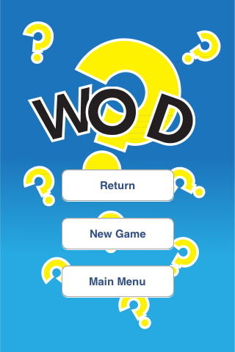**Menu Screen:** User can pause the game by clicking the “**Menu**” button from the game screen at the top left corner.

Click “**Return**” button to continue the game.

Click “**New** **Game**” button to start a new game.

Click “**Main Menu**” button to go back to the home screen/main menu.

**Pic 1.8 (Menu Screen)**